**Application Form**

**Care Food Cooking Competition 2024**

**Travel with Care Food**

**Application Deadline:** 28th July, 2024 (Sunday), 5:00 p.m.

**Submission Method:** Email to [goodlife@hkcss.org.hk](mailto:goodlife@hkcss.org.hk)

(Please specify in the email subject: Care Food Cooking Competition 2024)

*Remark: The organiser will send a confirmation notice via email to the contact person within three working days after receiving the application form. If you do not receive any notification by then or have any questions, please call 2876 2461 / 2876 2498 for inquiries.*

**Notification of Finalists:** 6th August, 2024 (Tuesday)

**Workshop Dates:** workshop 1: 17th August, 2024; workshop 2: 7th September, 2024

**Final Date:** 19th October, 2024 (Saturday)

***Care Food Cooking Competition Award Ceremony:***

23rd November, 2024 (Saturday)

*Remark: Shortlisted candidates have to attend the workshops, the final and the award ceremony.*

Part 1: Personal Information

Name: (Chinese) ____________________________ (English*)____________________________________

Phone Number: _______________________ Email Address:_____________________________________

*Please write in block letters

**Part 2: Details of Recipe** *(If the space provided is insufficient, please add additional page by yourself)*

*\*Finalists should use the recipe submitted for the final. However, candidates can adjust the ingredients, portions, and cooking methods according to the dish requirements after the pre-competition activities.*

1. Name of the dish: __________________________________________________________________
2. Ingredients and Quantities (Please list the names and quantities/units of all ingredients)

Ingredients:

|  |  |  |  |  |  |
| --- | --- | --- | --- | --- | --- |
|  | Name | Quantity/Unit |  | Name | Quantity/Unit |
| 1 |  |  | 5 |  |  |
| 2 |  |  | 6 |  |  |
| 3 |  |  | 7 |  |  |
| 4 |  |  | 8 |  |  |

Seasonings/Sauces:

|  |  |  |  |  |  |
| --- | --- | --- | --- | --- | --- |
|  | Name | Quantity/Unit |  | Name | Quantity/Unit |
| 1 |  |  | 7 |  |  |
| 2 |  |  | 8 |  |  |
| 3 |  |  | 9 |  |  |
| 4 |  |  | 10 |  |  |
| 5 |  |  | 11 |  |  |
| 6 |  |  | 12 |  |  |

1. Cooking Steps (In point form)

**Part 3: Dish Design Concept and Story Behind** *(If the space provided is insufficient, please add additional pages)*

1. Design concept and story behind the dish:

(II) Photo or Video Introduction of the Dish

1. **Photos**: Can be attached and emailed to goodlife@hkcss.org.hk, maximum 5 photos can be uploaded.

• Image type: JPEG/PNG colour photos, file size: 2MB or less each. The file name must include the participating unit and the theme of the work (Example: "Participating unit_Theme of the work")

1. **Video**: The video should no more than 3 minutes and upload it to cloud drive, set the video access to anyone with the link, and email the link along with this form to goodlife@hkcss.org.hk.

Video format: MP4, WMV, MOV

*\** *Will not affect whether the participants are shortlisted*

1. Do you have any caregiving tips/skills to share?

1. How much do you know about Care Food? (10 is the highest score)

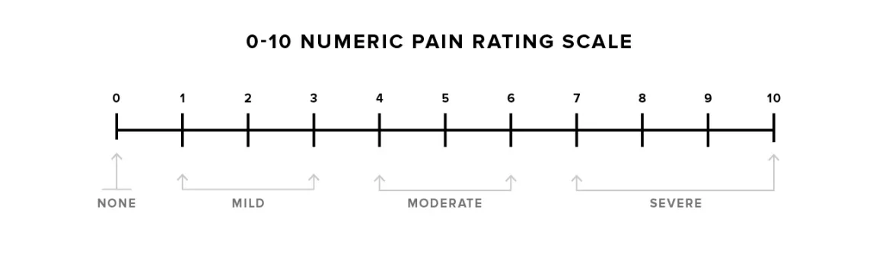

1. Why are you interested in Care Food?

1. Do you think the Guideline of Care Food Standard is helpful to you?

☐ Very Helpful ☐ Slightly Helpful ☐ Average ☐ Not Helpful

☐ Not Had the Chance to Learn yet

1. Expectations for the Competition: (optional)

________________________________________________________________________________________________________________________________________________________________

**Part 4: Questionnaire\***  *(If the space provided is insufficient, please add additional pages)*

1. Where do you know this Competition?

☐ HKCSS Promotion Platforms ☐ Social Welfare Organizations

☐ Speech Therapists/Dietitians ☐ Caregiver Platforms/Groups

☐ Food Suppliers ☐ Others (Please specify)___________________________________

1. Are you a local carer or a foreign domestic helper?

☐ Local Carer ☐ Foreign Domestic Helper

1. Language Proficiency

|  |  |  |  |  |  |  |  |  |
| --- | --- | --- | --- | --- | --- | --- | --- | --- |
| Language and Skills | Spoken | | | | Reading | | | |
|  | Fluent | Fair | Marginal | Incomprehensible | Fluent | Fair | Marginal | Incomprehensible |
| Chinese (Cantonese) |  |  |  |  |  |  |  |  |
| English |  |  |  |  |  |  |  |  |

1. If the submitted recipes, photos, and videos (if any) violate copyright laws, I accept disqualification from the competition and assume all legal responsibilities, unrelated to the organiser.
2. All information and documents in the application form are accurate and complete; the organiser is not responsible for any errors or omissions.
3. I understand and accept that the organiser collects, processes, and uses personal data and all submitted works for contact, promotion, and publicity purposes for this event.
4. I accept the organiser’s arrangement for filming or recording related to the competition and agree to participate in related promotional activities during the finals and after winning.
5. I agree that in any case, the organiser is not responsible for any claims arising from the Care Food Cooking Competition 2024, whether property or other losses, injuries, deaths, or other claims, whether due to the organiser or its employees, agents, contractors, and/or subcontractors’ intentional or negligent actions.
6. I agree to receive information from HKCSS via email. (If you disagree, please mark the box below with a “*✓*”)  
   ☐I refuse to receive information from HKCSS via email#.

**Part 5: Candidate’s Declaration**

*#Please mark✓in the appropriate box☐*

**Part 6: Terms and Conditions**  (*This section must be signed, otherwise the application will not be accepted)*

1. Each candidate can only submit one application form; duplicate applications will not be accepted.
2. The application deadline is 5:00 p.m. on Sunday, 28th July, 2024. Late submissions will not be qualified. Please submit the completed form via email to goodlife@hkcss.org.hk. HKCSS will announce the finalists on Tuesday, 6th August, 2024.
3. Candidates must comply with all competition rules, notices, declarations, and any requirements from the organiser. If there is any violation, the organiser reserves the right to disqualify the person from participating and winning the prize.
4. If any plagiarism or infringement is found, the organiser has the right to disqualify the candidate and the candidate must bear all legal responsibilities, unrelated to the organiser.
5. The organiser has the right to use and publish all submitted works (including recipes, photos, or videos) for publicity and promotion in any media without prior consent from the candidate.
6. All finalists must participate in pre-competition preparation activities. Absence without reason will result in disqualification.
7. All awardees must attend Care Food Cooking Competition Award Ceremony, absentees must explain the reason to the organiser. Organiser reserves the right to change any award arrangements.
8. If other candidates are found to have violated any rules or unfair practices during the competition, they must immediately report to the organiser or judges on-site or provide evidence to the organiser within seven days after the event. Other reports will not be accepted. Violators will be disqualified from the competition and awards.
9. The organiser reserves the final interpretation, modification, and changes of all competition rules and matters not covered.

Candidate's Signature: __________________________ Date:  _____________________________